**S VARSHA Design of Databases using DDL Language 14-Sep-23**

1. Open the command prompt Press WIN+R , type cmd

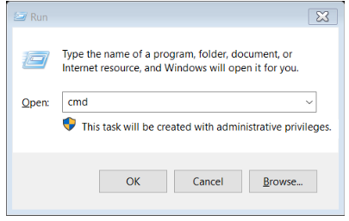

1. Once sqlplus prompt open then enter username and password it will connected

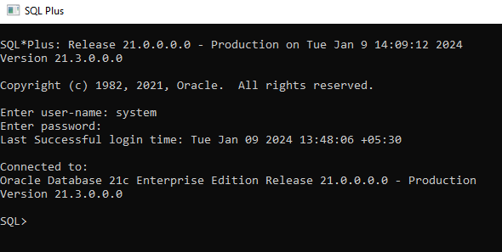

**EXPERIMENT-1**

**1. Write SQL queries to CREATE TABLES for various databases using DDL commands (i.e.CREATE, ALTER, DROP, TRUNCATE).**

Create table

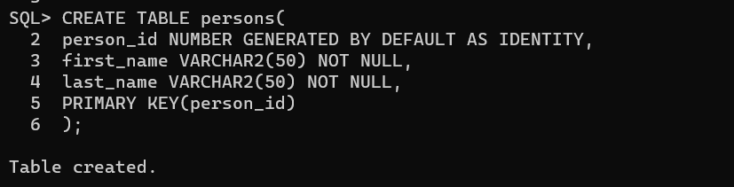

Desc table

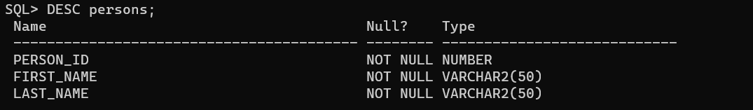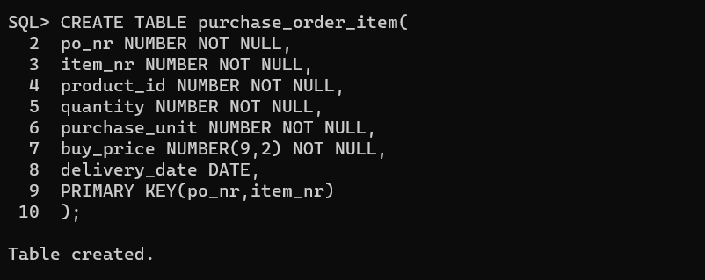

Alter table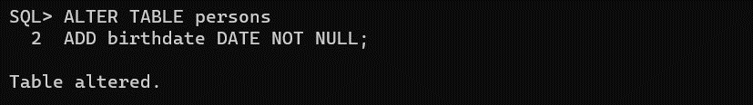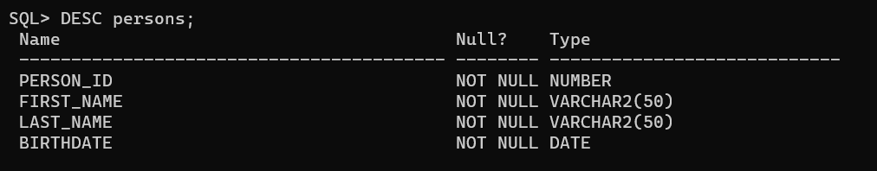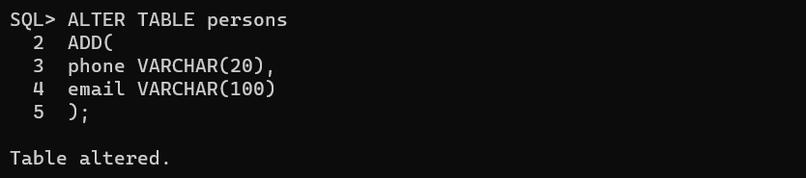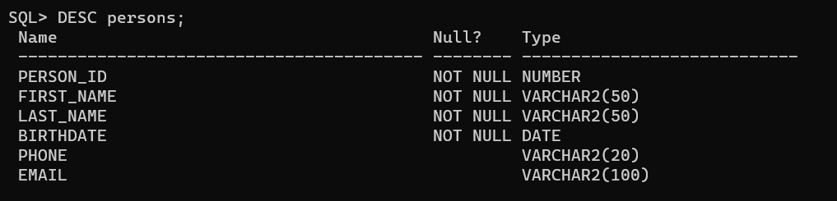

Drop table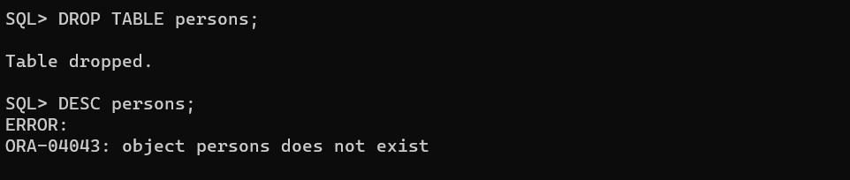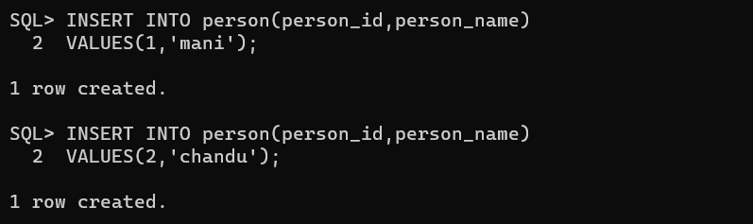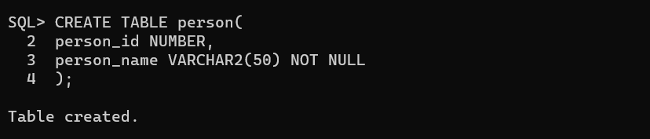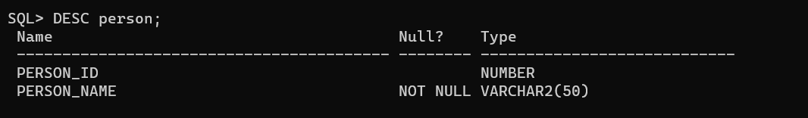

Truncate table

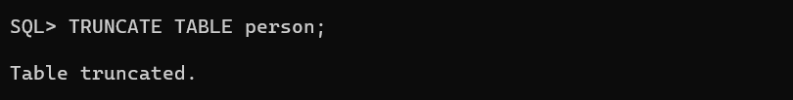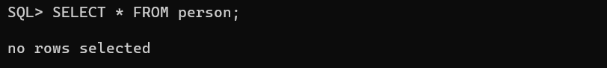

**EXPERIMENT-2**

**2. Write SQL queries to MANIPULATE TABLES for various databases using DML commands(i.e. INSERT, SELECT, UPDATE, DELETE,).**

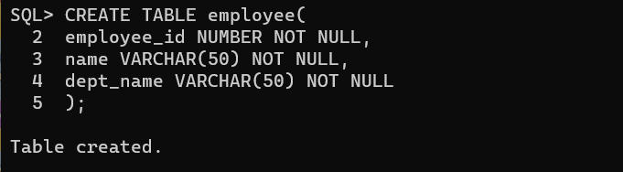

SELECT COMMAND

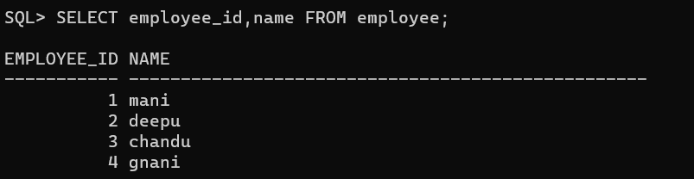

INSERT COMMAND

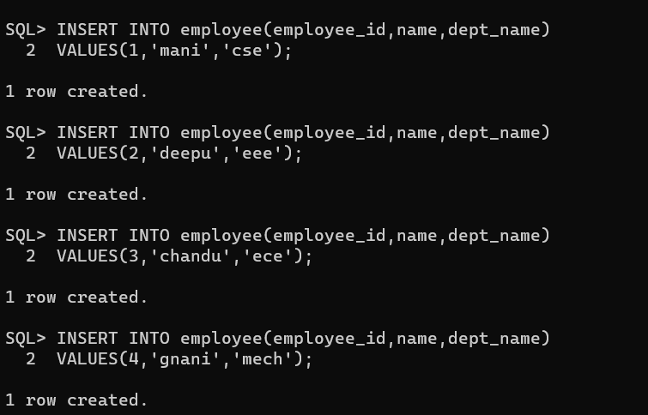

DELETE COMMAND

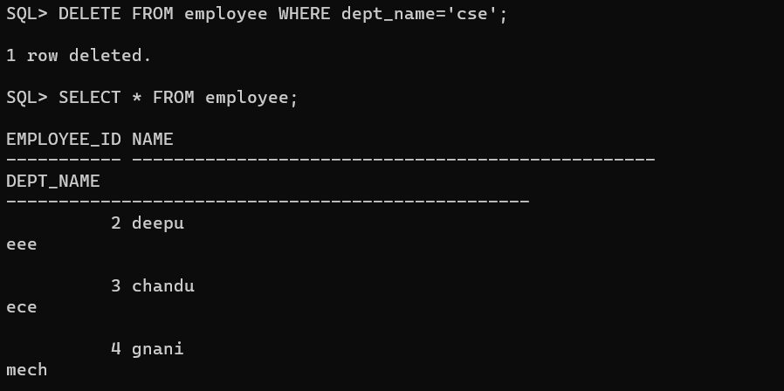

UPDATE COMMAND

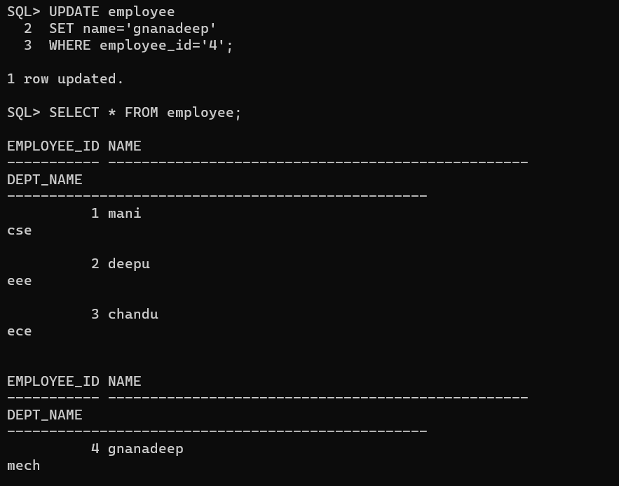

**EXPERIMENT-3**

**3. Write SQL queries to create VIEWS for various databases (i.e. CREATE VIEW, UPDATE VIEW, ALTER VIEW, and DELETE VIEW).**

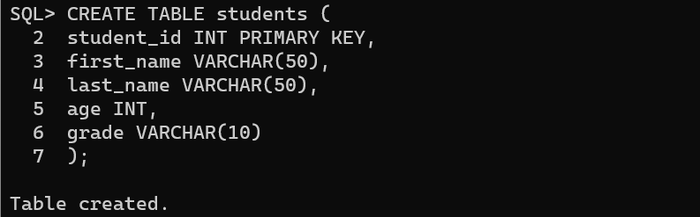

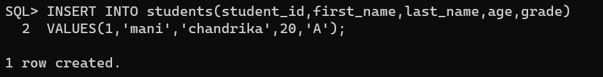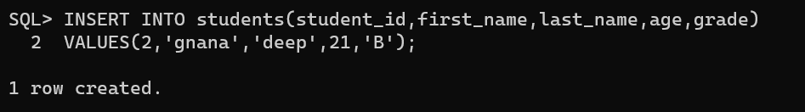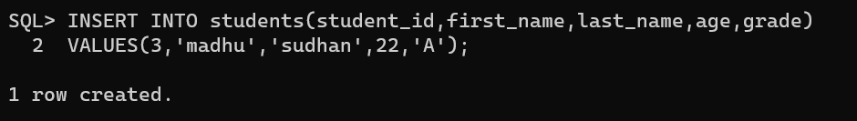

CREATE VIEW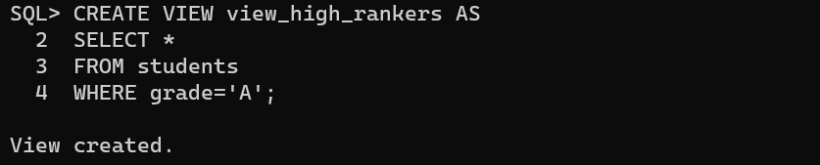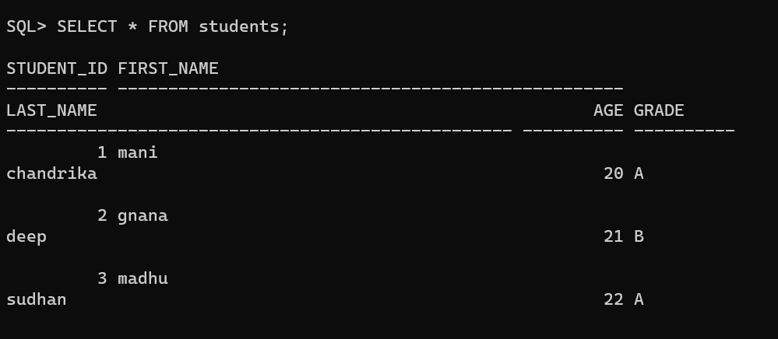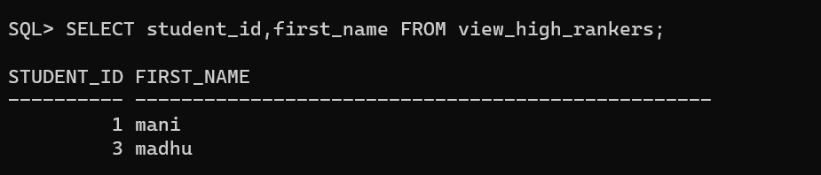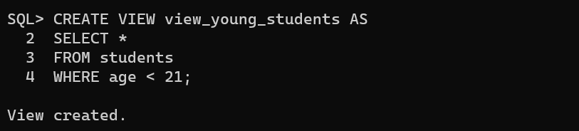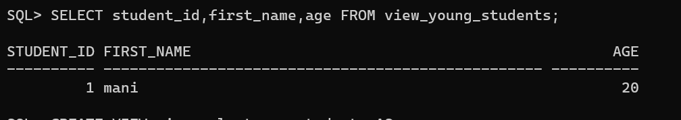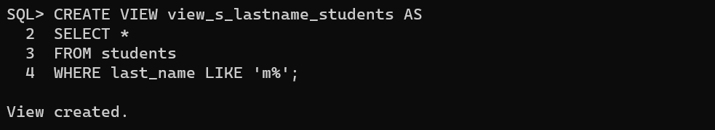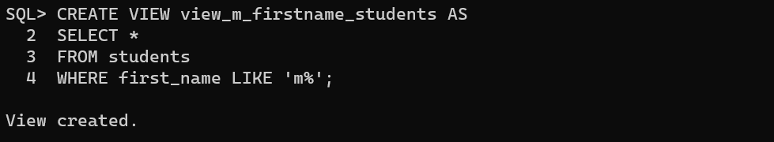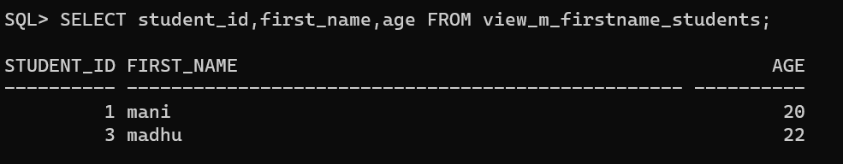

INSERT VIEW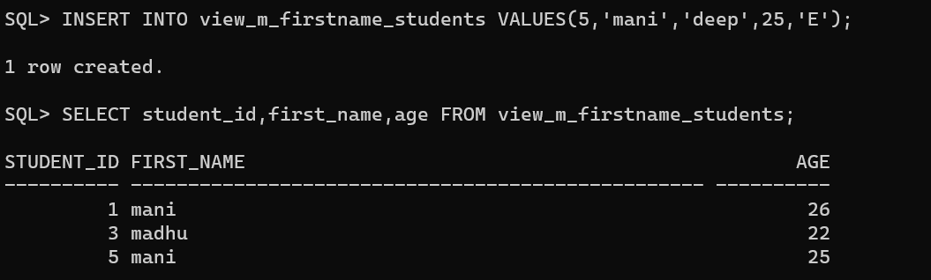

UPDATE VIEW

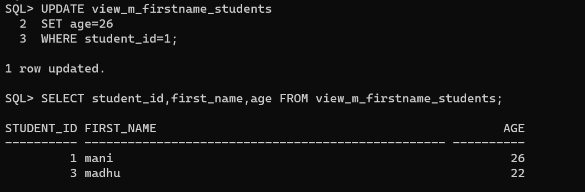

DELETE VIEW

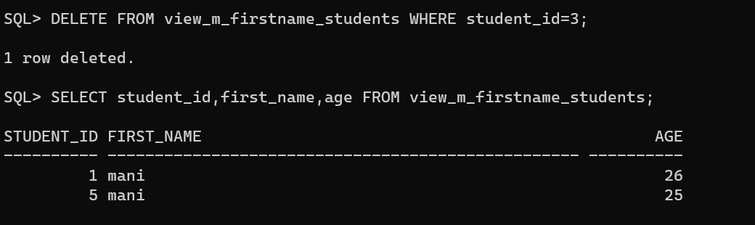

**EXPERIMENT-4**

**4. Write SQL queries to perform RELATIONAL SET OPERATIONS (i.e. UNION, UNION ALL,**

**INTERSECT, MINUS, CROSS JOIN, NATURAL JOIN).**

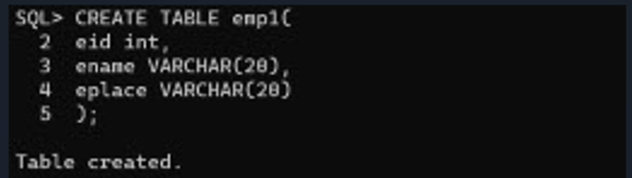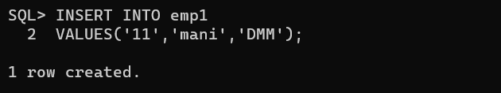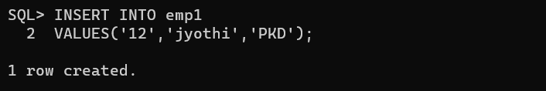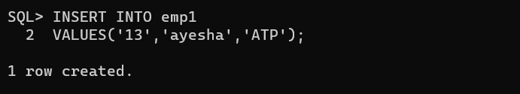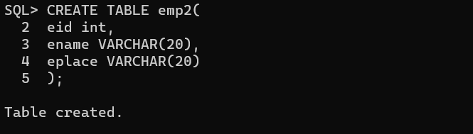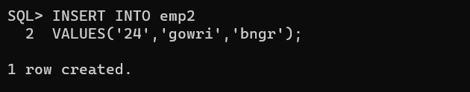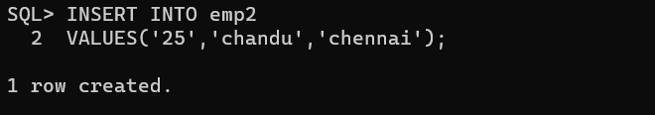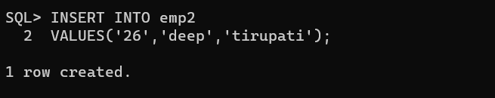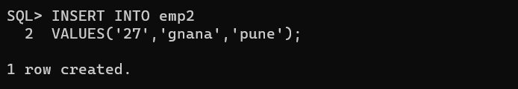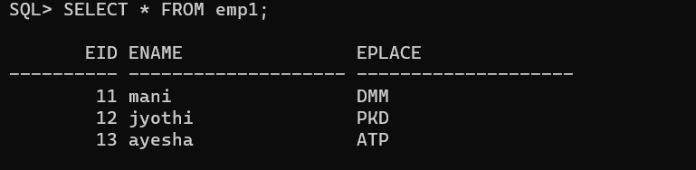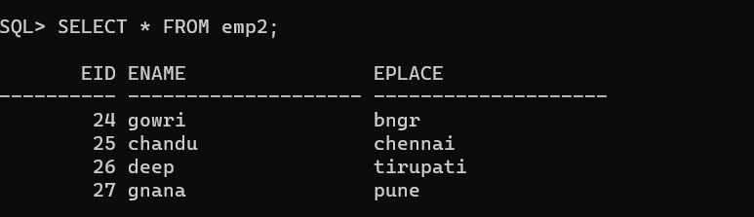

UNION

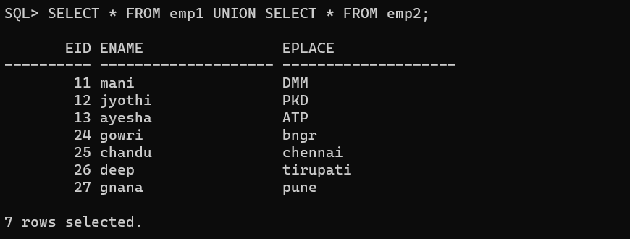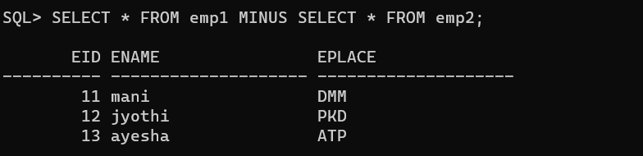

MINUS

UNION ALL

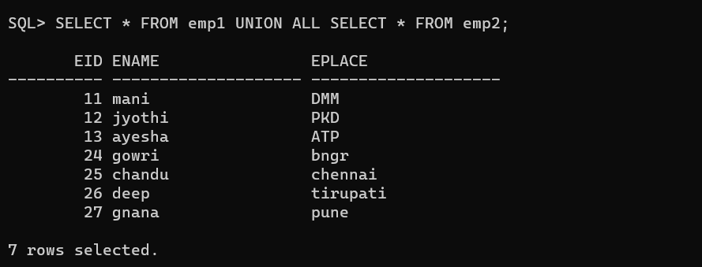

NATURAL JOIN

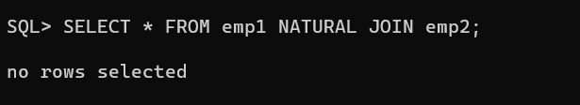

INTERSECT

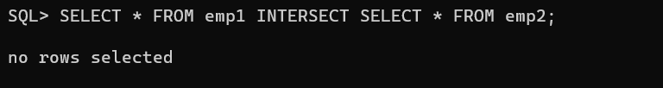

CROSS JOIN

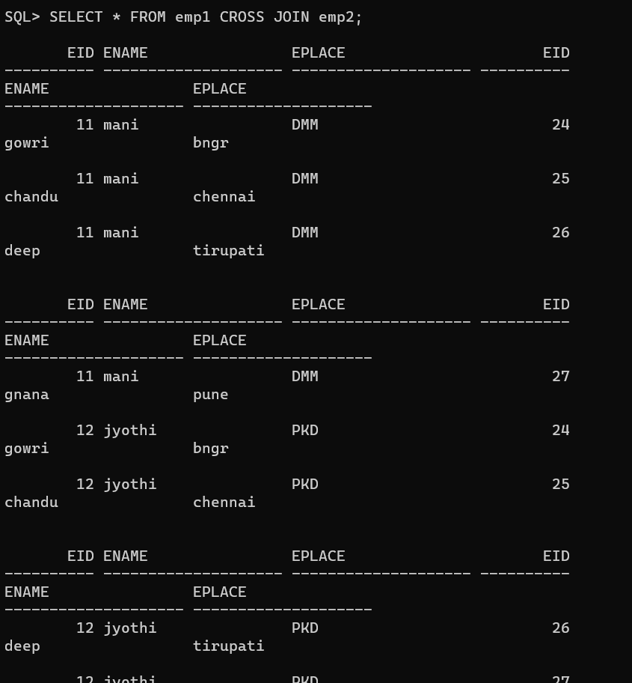

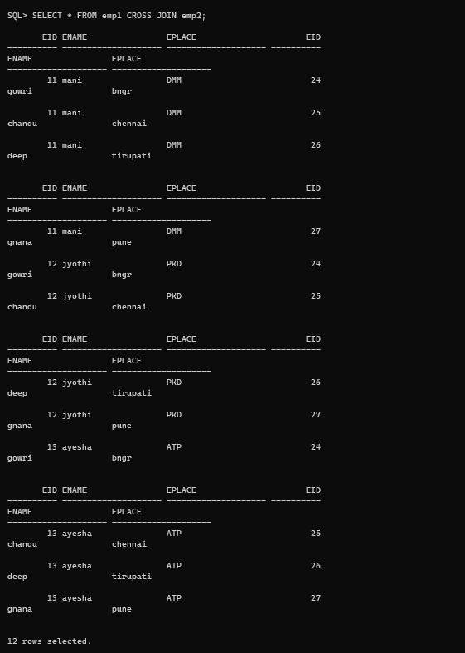

**EXPERIMENT-5**

**5. Write SQL queries to perform AGGREGATE OPERATIONS (i.e. SUM, COUNT, AVG, MIN,**

**MAX).**

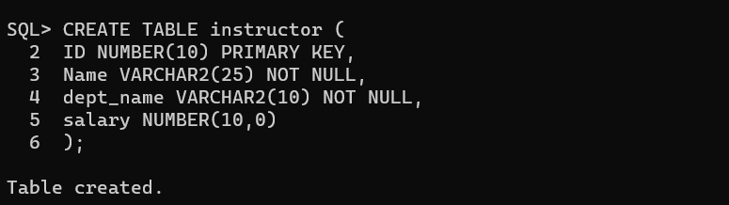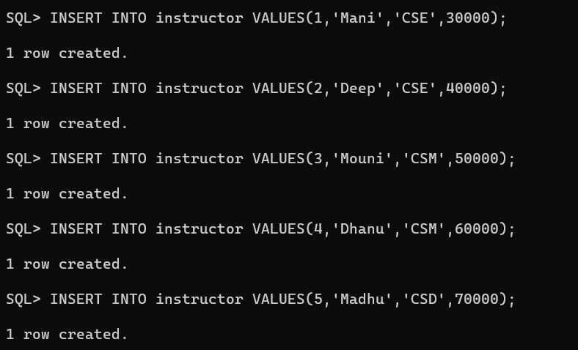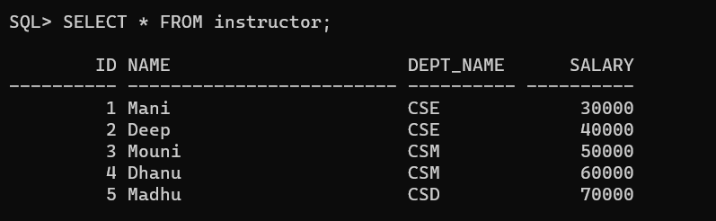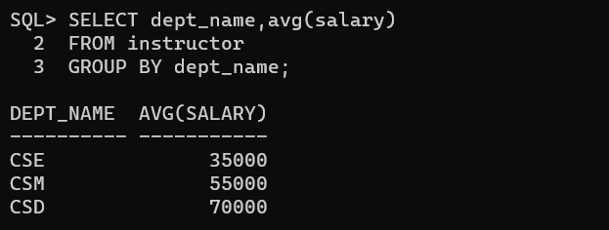

SUM

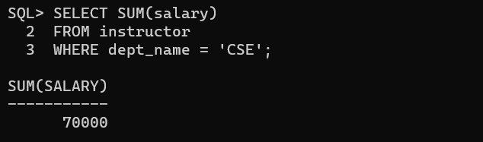

AVG

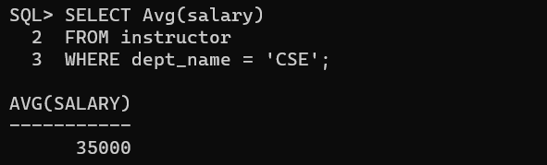

COUNT

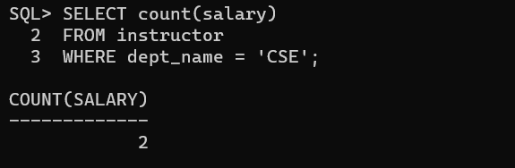

MIN

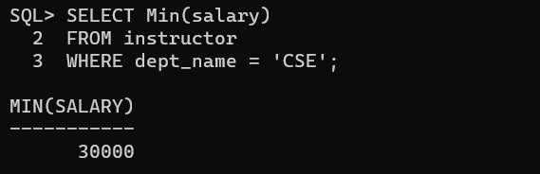

**EXPERIMENT-6**

**6. Write SQL queries to perform JOIN OPERATIONS (i.e. CONDITIONAL JOIN, EQUI JOIN,LEFT OUTER JOIN, RIGHT OUTER JOIN, FULL OUTER JOIN).**

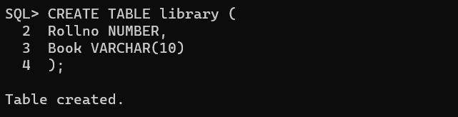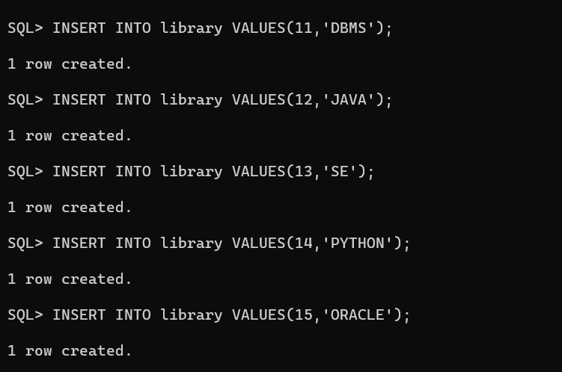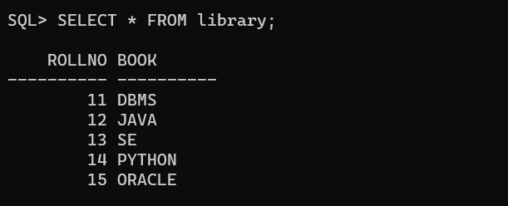

INNER JOIN

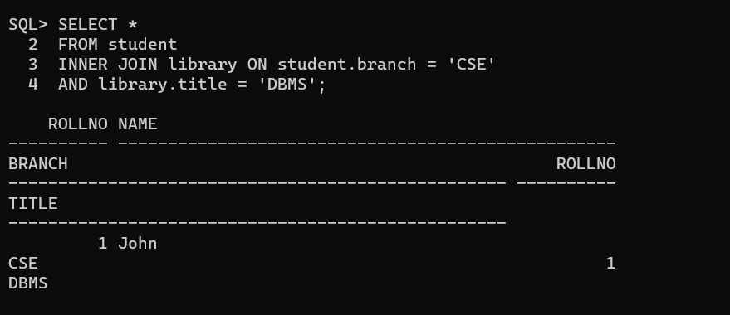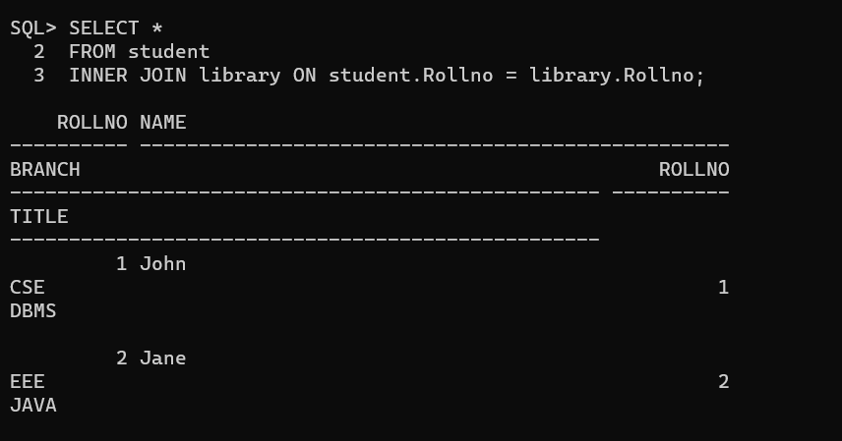

LEFT OUTER JOIN

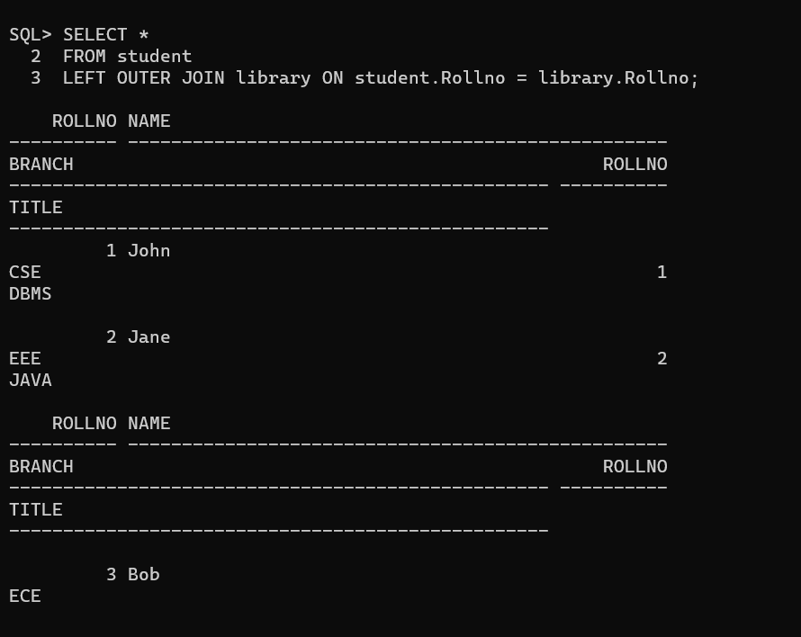

RIGHT OUTER JOIN

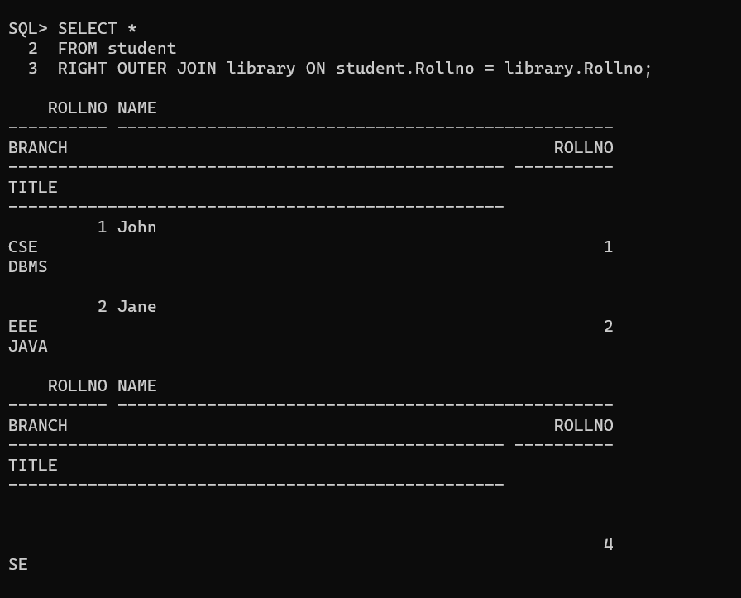

FULL OUTER JOIN

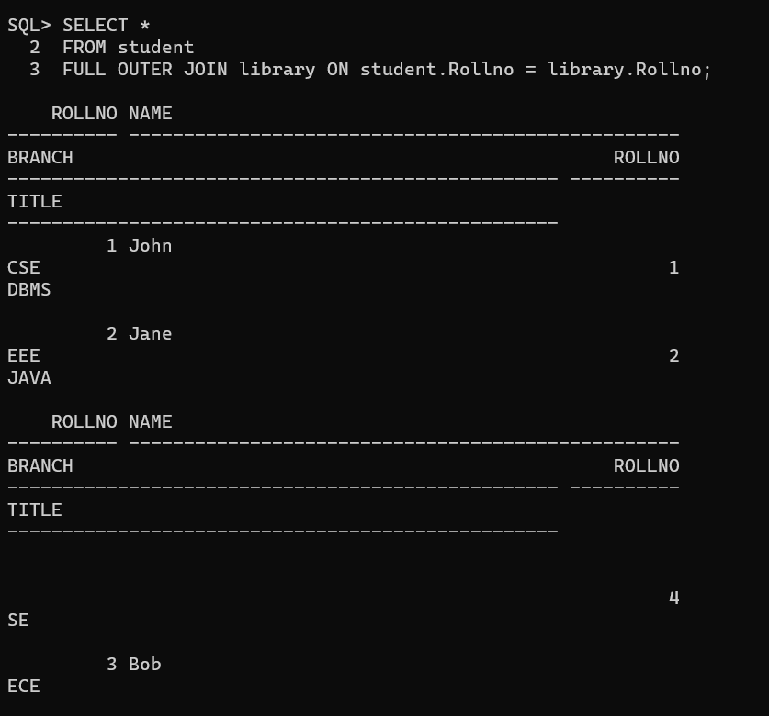

NATURAL JOIN

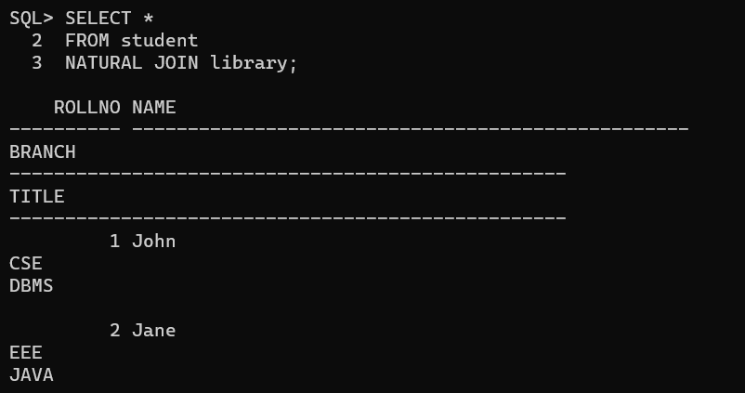

**EXPERIMENT-7**

**7. Write SQL queries to perform SPECIAL OPERATIONS (i.e. ISNULL, BETWEEN, LIKE, IN,EXISTS).**

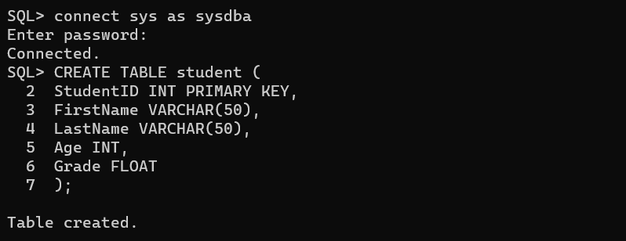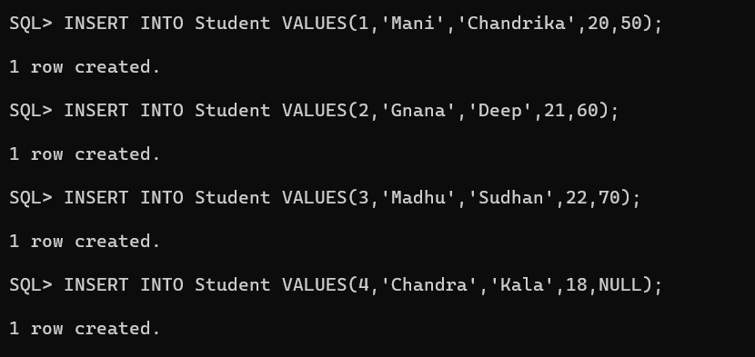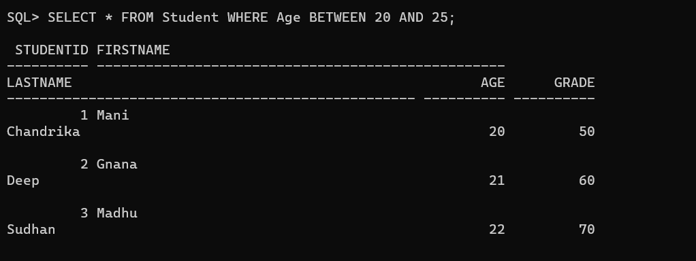

BETWEEN

IS NULL

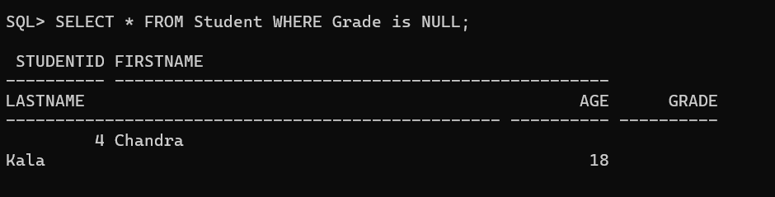

EXISTS

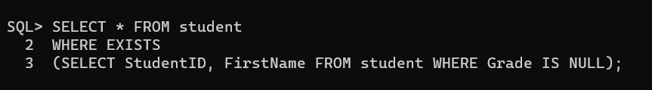

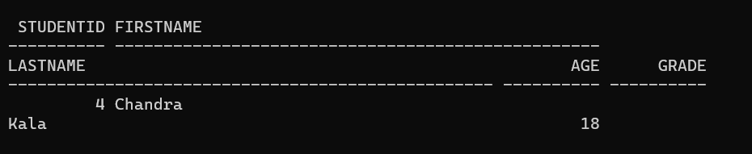

LIKE

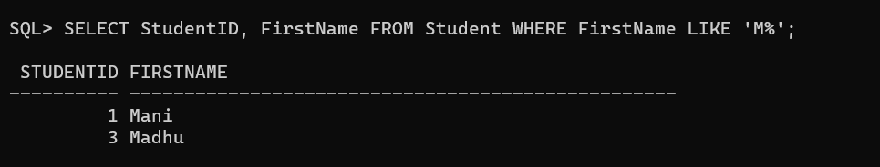

IN

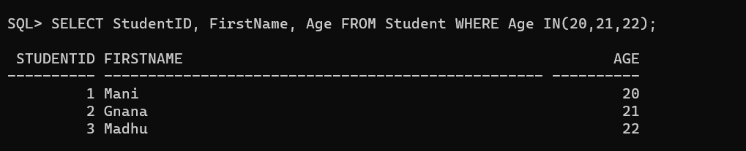

**EXPERIMENT-8**

**8. Write SQL queries to perform ORACLE BUILT-IN FUNCTIONS (i.e. DATE, TIME).**

UPPER

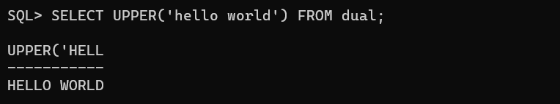

LOWER

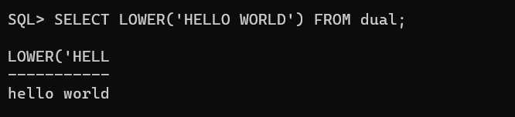

INITCAP

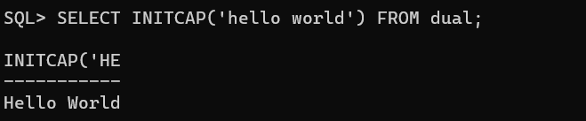

LENGT

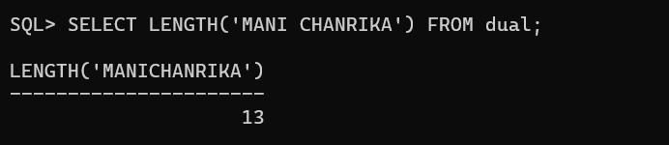

SUBSTR

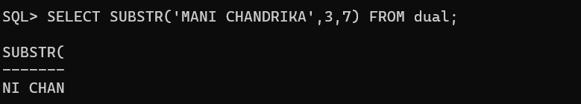

REPLACE

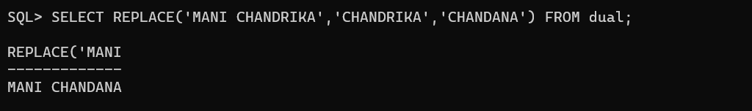

INSTR

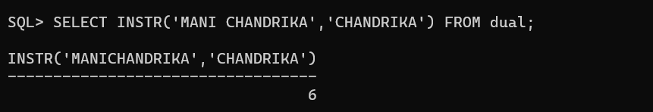

LPAD

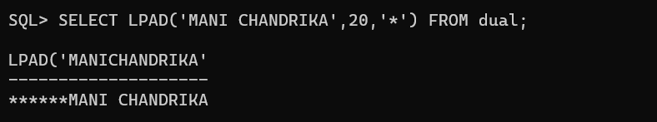

RPAD

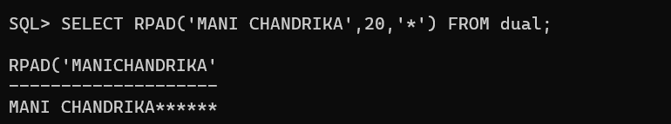

TRIM

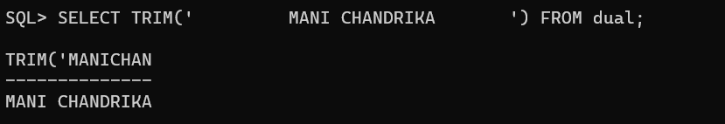

LTRIM

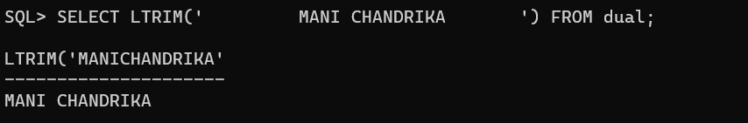

RTRIM

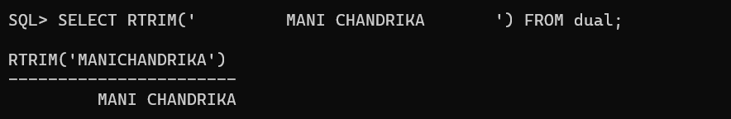

ROUND

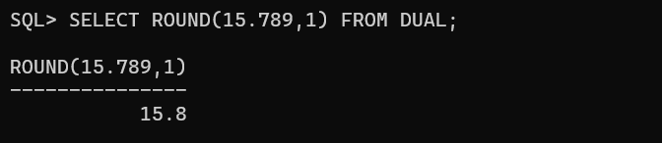

MOD

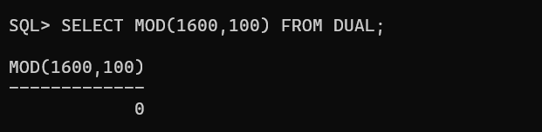

TRUNC

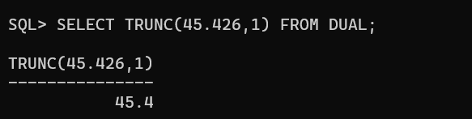

DATE

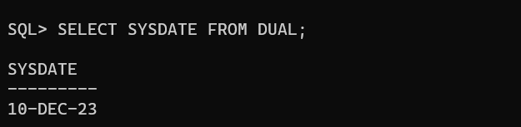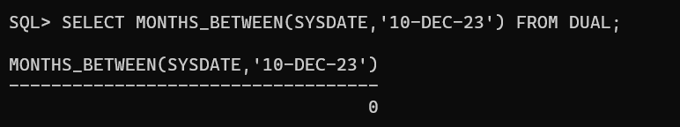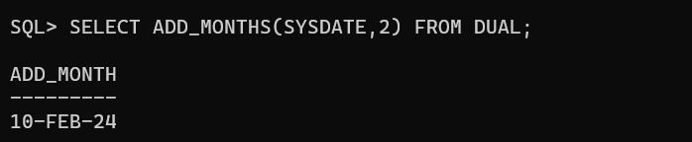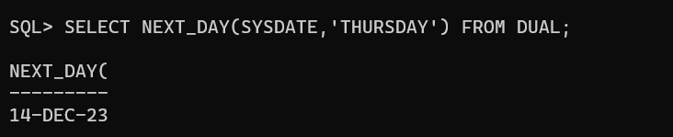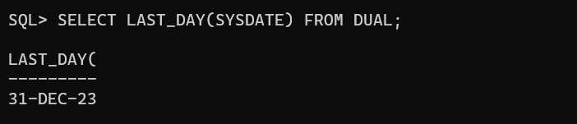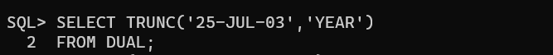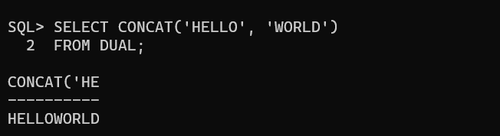

**EXPERIMENT-9**

**9. Write SQL queries to perform KEY CONSTRAINTS (i.e. PRIMARY KEY, FOREIGN KEY,UNIQUE NOT NULL, CHECK, DEFAULT).**

PRIMARY KEY

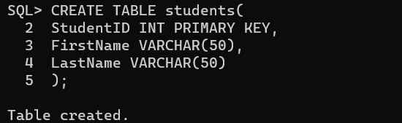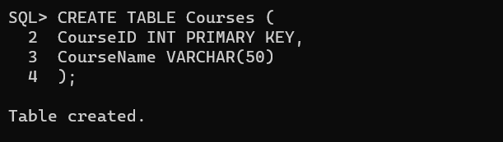

FOREIGN KEY

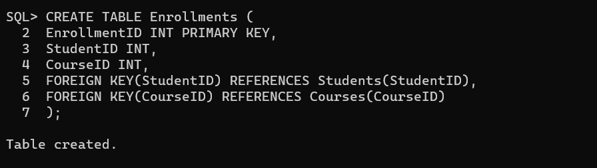

UNIQUE KEY

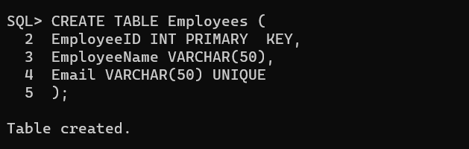

NOT NULL KEY

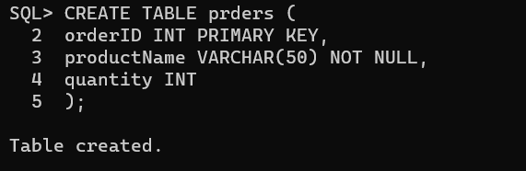

CHECK

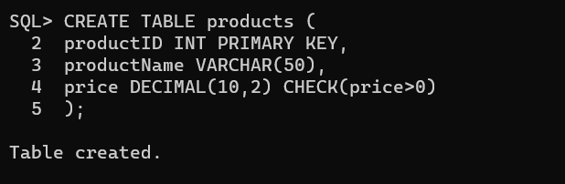

DEFAULT

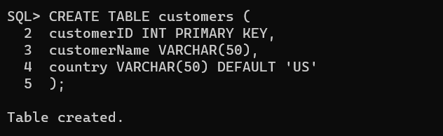

**EXPERIMENT-10**

**10. Write a PL/SQL program for calculating the factorial of a given number.**

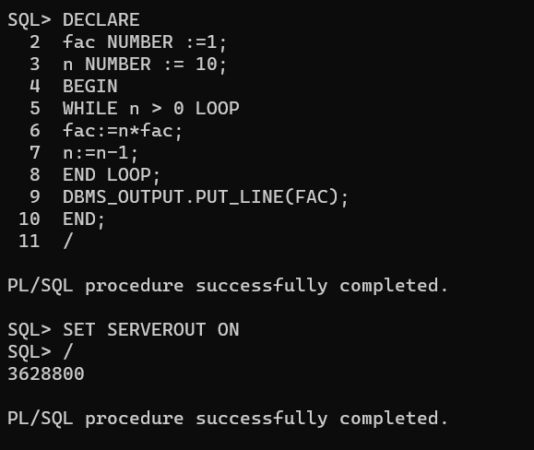

**EXPERIMENT-11**

**11. Write a PL/SQL program for finding the given number is prime number or not.**

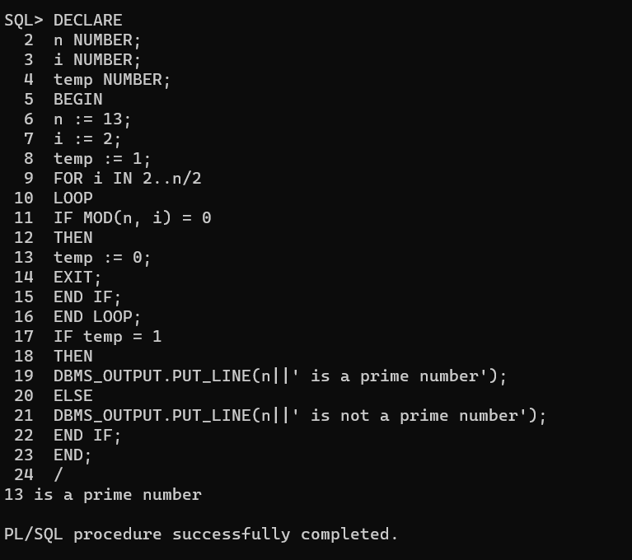

**EXPERIMENT-12**

**12. Write a PL/SQL program for displaying the Fibonacci series up to an integer.**

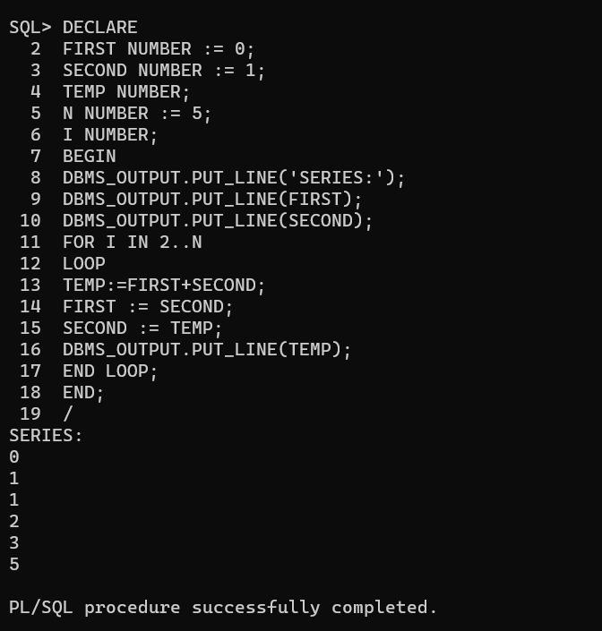

**EXPERIMENT-13**

**13. Write PL/SQL program to implement Stored Procedure on table.**

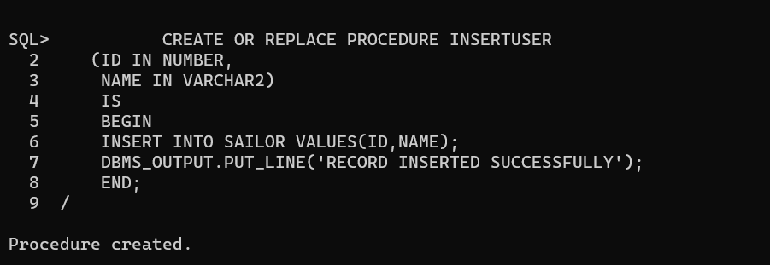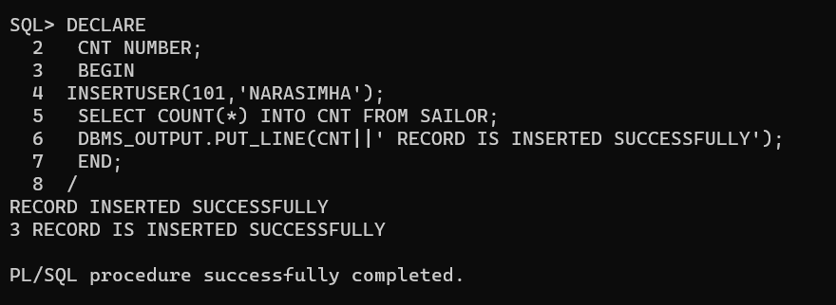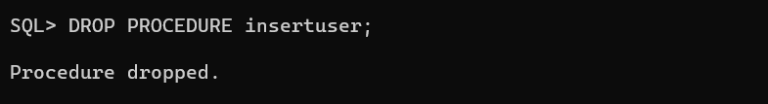

**EXPERIMENT-14**

**14. Write PL/SQL program to implement Stored Function on table.**

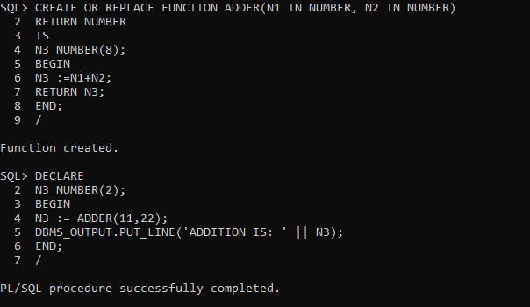

Recursive Fuction

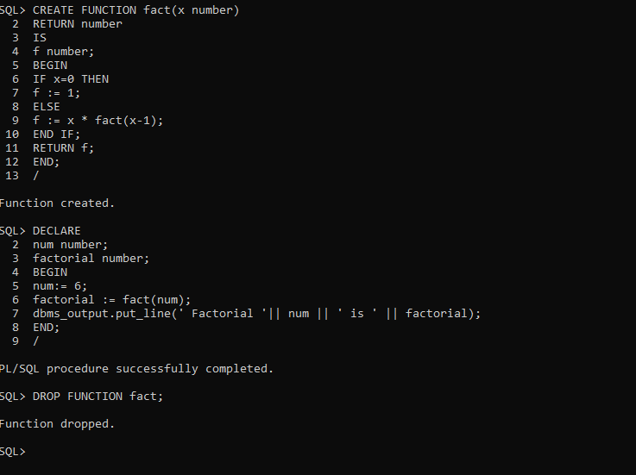

**EXPERIMENT-15**

**15. Write PL/SQL program to implement Trigger on table.**

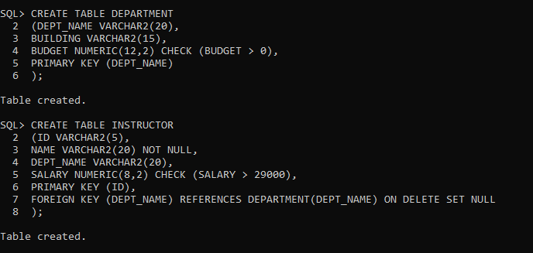

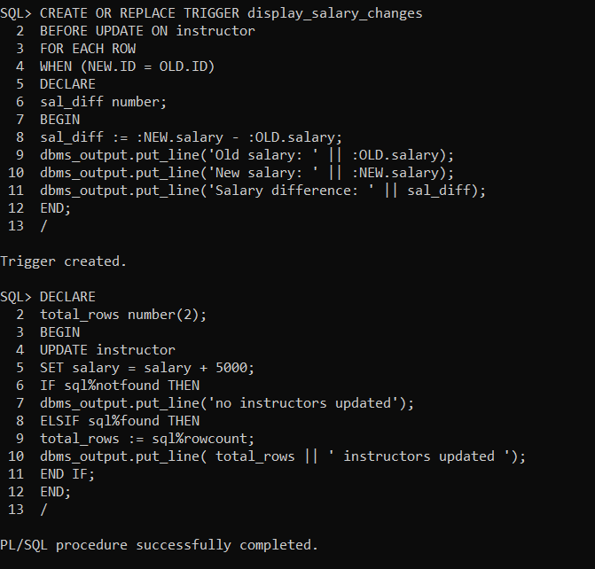

**EXPERIMENT-16**

**16. Write PL/SQL program to implement Cursor on table.**

**1. implicit cursor**

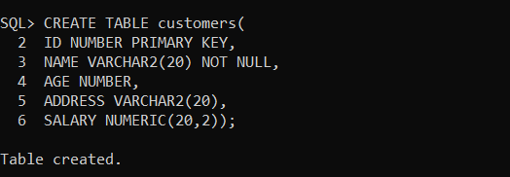

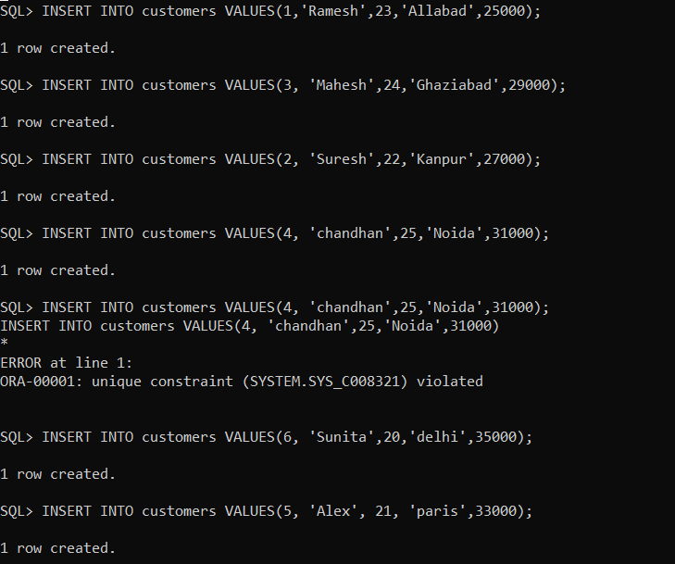

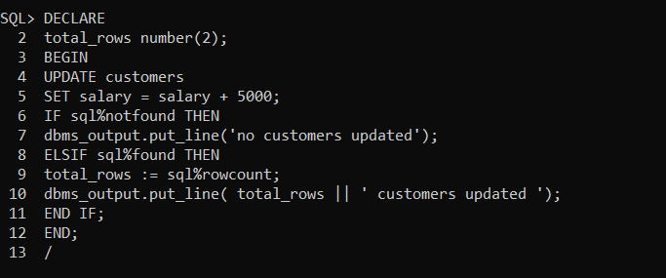

**EXPLICIT CURSOR**

